UNDERSTANDING SUPER STRUCTURES: PRACTICAL EXERCISE #2
STRESS CONCENTRATIONS|NEWSPAPER TENSION TEST
Introduction
You should be able to perform this exercise at home using an old newspaper to explore the effects of geometry on stress.
Objective
To estimate the stress concentration associated with geometrical features.
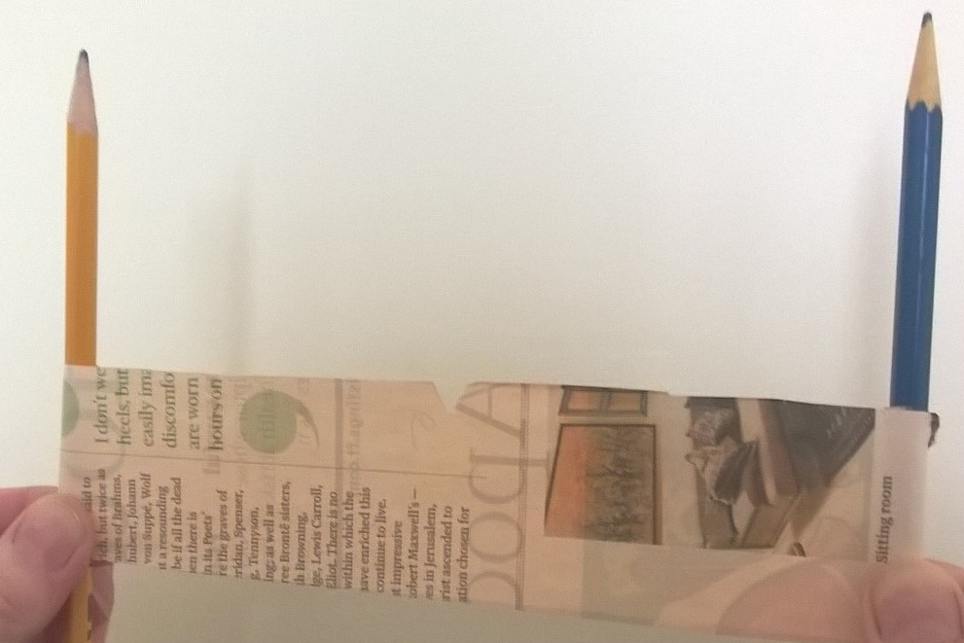
Figure 1: Tension test
Apparatus
You will need an old newspaper, a pair of sharp scissors, a ruler and two pencils.
Procedure
- Cut a strip of newspaper into strips approximately 30cm × 0.5cm.
- Roll each end of the strip around a pencil for a couple of turns; then holding the turns on the pencils, pull as hard as you can to snap, or fail the strip of newspaper in pure tension, as shown in figure 1. If you are able to snap the strip of paper, then cut a new strip with the width increased by 0.5cm and try again. Repeat this process until you cannot fail the strip of newspaper and record the width as $W$.
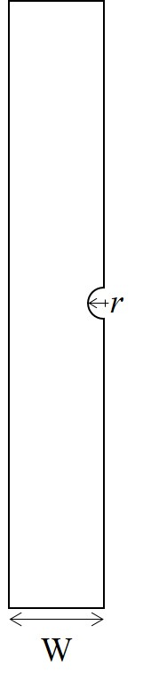
Figure 2: Diagram of test strip
- Take a fresh strip of newspaper of width, $W$ and cut a small semi-circular notch, of radius about 0.5cm, in one edge of the strip at its mid-point, as shown in figure 2. Now, wind the ends of this strip onto the pencils and snap the strip by pulling the pencils apart. If you are unable to snap the strip, then enlarge the semi-circular notch slightly and repeat the test. Again, failures close to the pencils should be discarded.
- Once you have established a notch radius, $r$ for which you can snap the strip of paper, repeat the test for two identical strips with semi-circular notches rolled together onto the pencils. If you can snap two strips, together then try three and then four and so on until you can’t snap the strips – note this number of strips of newspaper, $n$.
- Repeat #4 above for a vee-shaped notch of the same depth as the radius of your semi-circular notches used in #4.
Discussion/Analysis
For the first test with the plain strip of newspaper, when it snaps we can write:
$σ_{uts}=\frac{F_{snap}}{A}$ [1]
where $σ_{uts}$ is the ultimate tensile strength of the newspaper, $F_{snap}$ is the force applied at the instant when it snaps and $A$ is the cross-section area of the strip, equal to width, $W_{snap}$ multiplied by thickness, $t$. This is based on the definition of stress as force per unit area. When you were unable to snap a strip of newspaper of width, $W$ , we can assume you applied the maximum force that you could, i.e. $F_{max}$ and the stress induced is the force divided by the area [${F_{max}}/{Wt}]$. If the strip of paper did not snap then
$\frac{F_{max}}{Wt}{<σ}_{uts}$ [2]
But for the widest plain strip that you could snap
$\frac{F_{max}}{\left(W-0.5\right)t}{≈σ}_{uts}$ [3]
When there is a semi-circular [or vee-shaped] notch cut in the strips of newspaper then at the location of failure adjacent to the notch, the width is reduced to $(W-r)$. The condition in equation [3] applies for the maximum number of notched strips that you could snap, i.e. $(n-1)$, or one less than you could not snap and equation [3] becomes
$\frac{F_{max}}{\left(n-1\right)\left(W-r\right)t}{≈σ}_{uts}$ [4]
In the plain (un-notched) strip of newspaper, the stress, $σ_{average}\left(=F/A\right)$ is reasonably uniform across the width because we have used the pencils to help apply the loading uniformly. However, in the notched strips of newspaper, the stress concentrates around the notch, so that the stress at the notch tip is
$σ_{notch}=Kσ_{average}$ or $K=\frac{σ_{notch}}{σ_{average}}$ [5]
where $K$ is known as the stress concentration factor. When the notched strips of newspaper snap, $σ_{notch}=σ_{uts}$, but also when the plain strip fails, $σ_{average}=σ_{uts}$, hence substituting the two conditions from expressions [4] and [3] respectively into expression [5] gives:
$K=\frac{{F_{max}}/{\left(W-0.5\right)t}}{{F_{max}}/{\left(n-1\right)\left(W-r\right)t}}$ [6]
Hence, since $F_{max}$ and $t$ are constant in all of the tests:
$K=\left(n-1\right)\frac{\left(W-r\right)}{\left(W-0.5\right)}$ [7]
Now, you can work out the stress concentration factors for the semi-circular notch and vee-shaped notches using your values for $r,$ $n$ and $W$ from the tests.
Conclusions
What values of stress concentration factor did you get for the semi-circular notch and vee-shaped notch?
Why are these concentration factors not the same?
What causes a premature failure at the pencils?
How accurate are your results? Do you have any suggestions for improving the experiment?

I did the experiment. I managed to snap a strip of width ~1.5 cm but not at 2cm wide. So, my W = 2. I actually broke one of my pencils in the process of doing this part!! I used American pencils left over from our time there – they must make stronger pencils in the USA!

If it snaps close to where you are holding the pencils, then it does not count and you should repeat the test and holding the pencils more carefully without touching the newspaper that is not wound onto the pencils.

